**Microsoft Azure Virtual Training Day: Azure Data Fundamentals Day 2**

Online free training from MS 29/09/2021

Contents

Resources 2

Introduction 2

Module 3 – Explore non-relational data in Azure 4

Explore non-relational data offerings in Azure 4

Explore provisioning and deploying non-relational data services in Azure 8

Migrate Data to Azure Cosmos Dbase 14

Azure authentication 16

Azure Lake Storage Account 17

Manage non-relational data stores in Azure 21

Configure consistency 21

Query 21

Demo using Core SQL API 22

Aggregate Functions 23

Create FileShare 25

Copy to Fileshare 27

Module 4 – Explore Modern Data Warehouse Analytics 30

Examine components of a modern data warehouse 30

Data Factory 32

Azure Data Lake 33

Azure Data Bricks 33

Azure Synapse Analytics 33

Azure Analysis Services 34

HD Insights 34

Explore data ingestion in Azure 35

Explore data storage and provisioning in Azure 36

Azure Synapse Analytics 36

Azure Synapse Analytics 37

Demo Load Data to Azure Synapse Analytics 37

Get started building with Power BI 48

# Resources

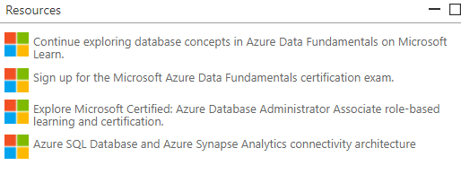

# Introduction

Learn the fundamentals of core database concepts in a cloud environment. Join us at Microsoft Azure Virtual Training Day: Data Fundamentals to build your foundational knowledge of cloud data services. Explore relational and non-relational data offerings as well as big data and modern data warehouse analytics solutions in Azure.

Attend this training to:

* Learn the roles, tasks and responsibilities involved in managing data in a cloud environment.
* Gain basic skills for working with relational and non-relational cloud data services in Azure, including provisioning and deploying relational and non-relational databases.
* Explore processing options for building data analytics solutions, including Azure Synapse Analytics, Azure Databricks and Azure HDInsight.
* **Welcome!**
* Hello everyone! Thank you for joining todays webinar. There is a list of resources available on your screen now. Please feel free to ask the live moderator questions within this chat box. If you are having technical issues, please click the question mark, Help widget on your screen. Remember to keep an eye on the Microsoft UK Training Days webpage for more events coming up <https://www.microsoft.com/en-gb/events/training-days>/ . Enjoy the session! – 'The Microsoft Training Days' Event Team​
* **Agenda**
* 10.00 – 10.03​ Introduction​ 10.03 – 11.10​ Explore Core Data Concepts​ 11.10 – 11.20​ Break-10 minutes​ 11.20 – 12.10​ Explore Relational Data in Azure (Segment 1 of 2)​ 12.10 – 12.20​ Break-10 minutes​ 12.20 – 12.55​ Explore Relational Data in Azure (Segment 2 of 2)​ 12.55 – 13.25​ Closing Q&A​
* **Free Exam Information**
* Once you have completed all of this training you are eligible to take the DP-900 certification exam at no cost. You will receive a 'Thank You' email in the next 5 working days with steps on how you can claim and schedule your exam. You have 90 days from after the session to schedule the exam. The exam will be online and you will have 40-60 multiple questions with 60 minutes to complete. You have one attempt to pass the exam for free, after this there will be a cost of $99 but we are sure you will pass first time! There are no official Microsoft practice exams. There are several paid options available through LinkedIn Learning, Measure Up, and a number of other providers. However, we recommend that you check out the knowledge checks at the end of each of the modules in the learning path which is the first link in your resources box. Good Luck!

After completing this free training, you’ll be eligible to take the [Microsoft Azure Data Fundamentals certification exam](https://docs.microsoft.com/learn/certifications/exams/dp-900) at no cost.

Here’s what you can expect:

|  |  |
| --- | --- |
| **Part 1** | **Part 2** |
| Introduction | Introduction |
| Explore Core Data Concepts | Explore Non-relational Data in Azure (segment 1 of 2) |
| Break: 10 minutes | Break: 10 minutes |
| Explore Relational Data in Azure (segment 1 of 2) | Explore Non-relational Data in Azure (segment 2 of 2) |
| Break: 10 minutes | Break: 10 minutes |
| Explore Relational Data in Azure (segment 2 of 2) | Explore modern data warehouse analytics in Azure |
| Closing Q&A | Closing Q&A |

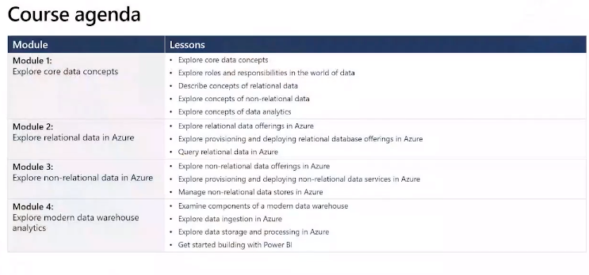

# Module 3 – Explore non-relational data in Azure

## Explore non-relational data offerings in Azure

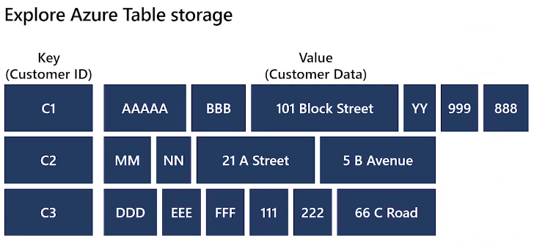

Uses Azure nosql key/value store

Items referred to as rows

Values/fields are referred to columns

All rows must have **key** but the columns can vary

No concept of relationships, foreign keys, index, etc

Tables are generally denomalised

Each row holds all the info for an entity

Number of columns can differ per row/entity

Quick data retrieval as all info can be accessed in same row using the entity key.

Azure Table storage Table splits table into partitions – used to group related rows based on a common partition key

Partition key – identifies the partition

Row key – identifies a row of data

Row key stored in order in partition

Can have complex key of both partition and row key.

Terabytes of structured data e.g. product catalogues, customer info

Fast access using Azure table storage

Good for quick capture and storage IOT (Internet of Things) data

Each device can have it’s own partition and rows date/time senor data collected

Category = footware, Row = boots

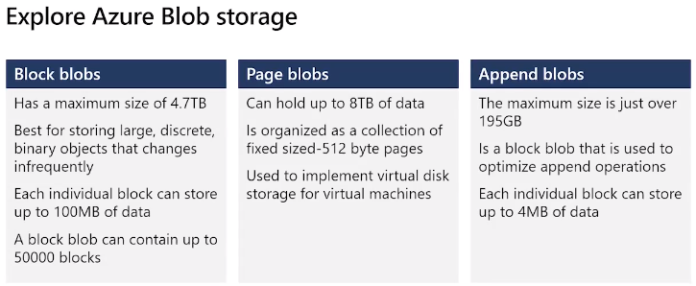

Create blob storage account under Azure Storage Account

Create container in the Storage Account

Specify blob type as above

Container lets you group blobs together

Can have folders within container with different blobs

Can have different permissions on containers and blobs

Can chose tier to store blob – high tier, core tier – different pricing

1. Frequent access = high/hot tier – more expensive (high performance media)
2. Less frequent access = core/cool tier – cheaper (lower performance media)  
   Latency ~ milisections
3. Archive tier – stored in offline state  
   Latency ~ hours  
   Must first start it up – change to a hot or cool tier

Can create in hot tier and as get less usage move to cool or archive tier

Blobs replicated 3 times in same region or can pick different region at additional cost.

Soft delete allows recovery of deleted blob

Snapshot – read only of a blob at a time

Change feed – monitor changes, ordered, read-only, changes to a blob

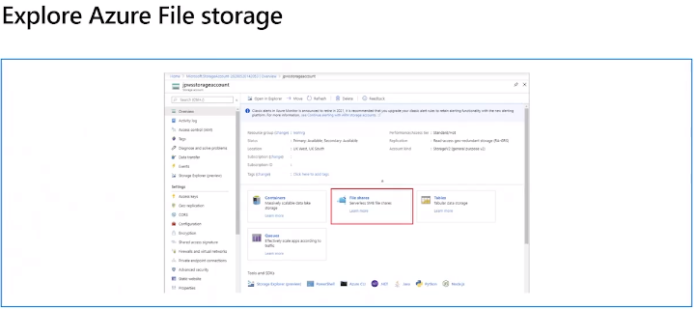

On-prem store on one computer and give access to users on other computers but restricted to network

Azure file stores in cloud – can move current fileshare to Azure cloud File Share

Fileshare protocol used so can access anywhere with internet connection

Can restrict access using Azure authentication e.g. AD

Create filestore below your Azure Storage account

Can share up to 100TB in single storage account

Fully managed service

Can move docs to cloud fileshare and can sync to on-prem fileshare to move files

Data encrypted at rest (can also encrypt in transit)

Replicated to region or can be geo replicated to a different region

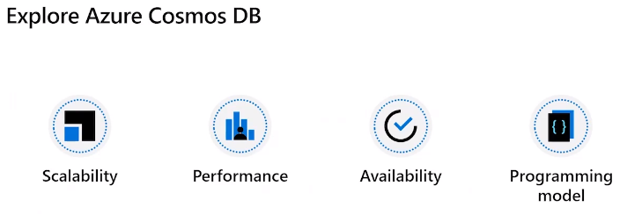

Azure Cosmos DB - Multi-model Nosql database.

Partition separated DB store

Document up to 2MB including binary objects

Uses json to structure database – values curly braces, each item identified by a name

Stored in containers

Partition key relates documents together

Reduces I/O for query to retrieve specific documents

Also has index to track values of all fields within document – can use this to query for a particular field without having to scan full doc store.

* Docs in containers
* Docs have partition key to relate the documents together
* Reduces I/O for doc retrieval

Example customer has partition id so can retrieve all customer orders as single I/O

Docs in Azure Cosmos DB has index – as well as document and partition id.

Can use this auto created index to query for field in doc

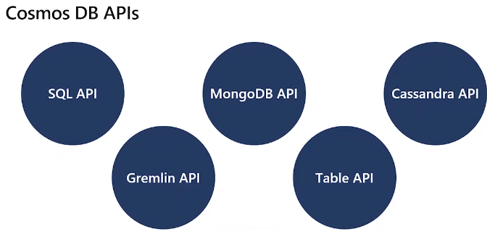

* Table API - allows switch between Azure table storage to Comos DB without having to change your storage
* Others support other dbms within the Comos DB so do not have to make many changes to migrate to Comos DB (or some like MongoDB let you access the existing tools to interact) storing data in Azure storage. Can migrate MongoDB to CosmosDB (In your Azure Storage Account) and still use the same applications you currently use to interact with your doc dbase

Support existing applications already using these dbms as backend data storage.

Main use is to support existing applications that use one of these databases as their backend. Can migrate to CosmosDB without changing front-end application.

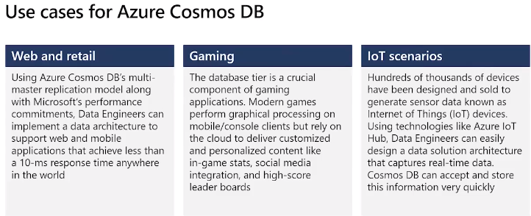

## Explore provisioning and deploying non-relational data services in Azure

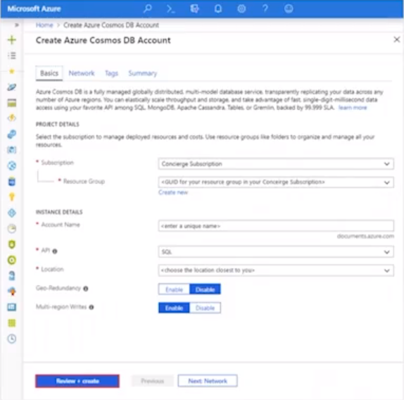

To provision can use

* Azure screen interface as above
* Azure CLI commands can be written as scripts
* PowerShell commands and as scripts (like CLI)
* Azure Resource Managed (ARM) templates to execute deployments (json code)

Demo

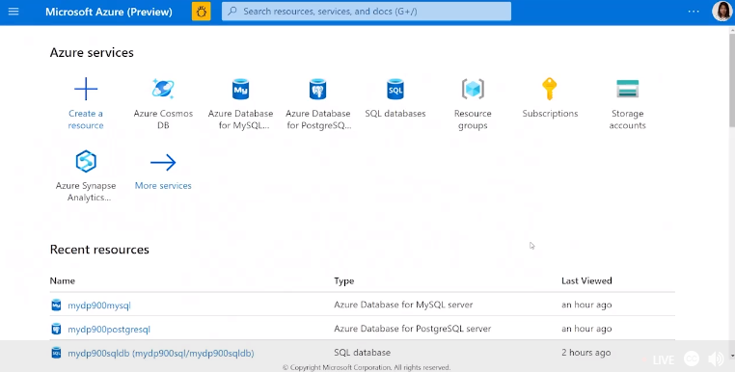

Search Comos DB – Add

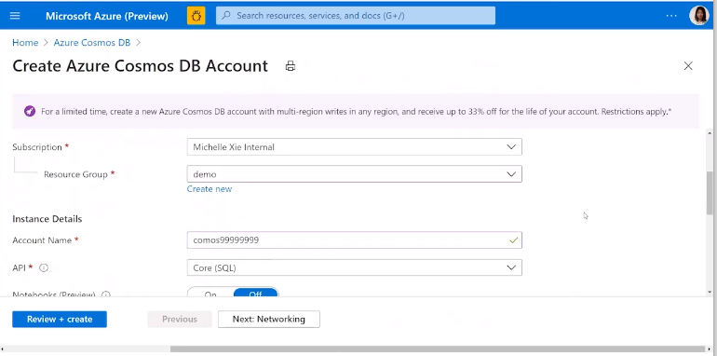

Subscription & Resource Group

Unique Name

Pick API – what queries we want to use against dbase, chose dropdown list

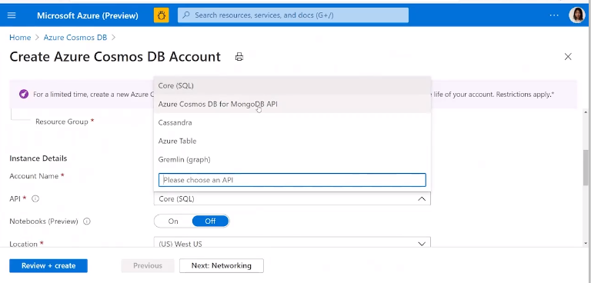

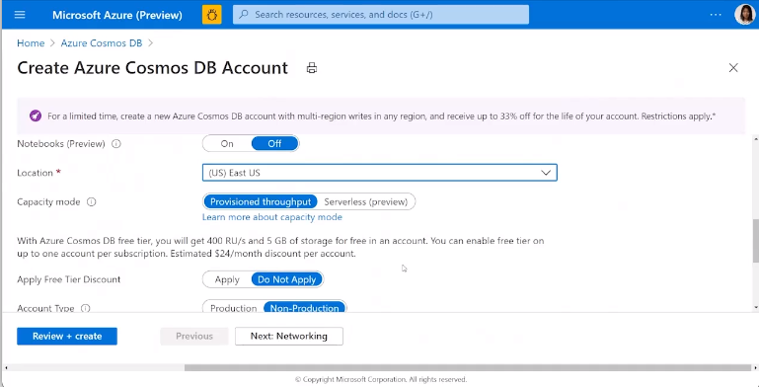

Region

Capacity mode:

* Provisioned Throughput – dedicated resource for your database – production database
* Serverless (preview) – given as needed not dedicated resources

Geo-Redundancy – allows failover to other regions

Multi-region writes – can write to multi master data in other regions

Can apply free tiers discount – can only apply once

Availability zones – if issues in one zone can keep working in other zone.

ETC

Network TAB

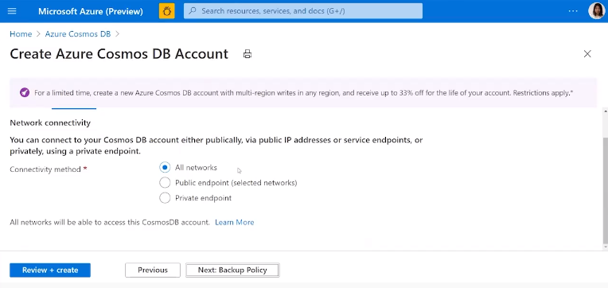

All networks – anywhere from internet

Public endpoint – state limited networks that can access

Private endpoint – block all access from public internet

**Backups**

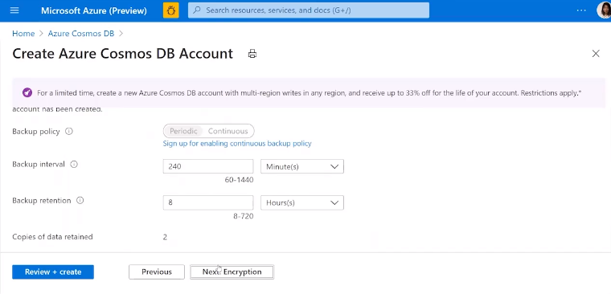

**Encryption**

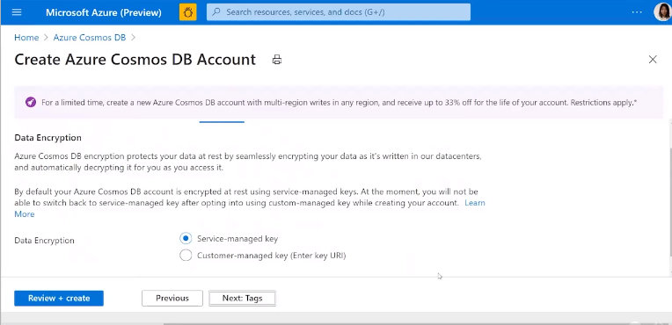

Tags – help find dbases – metadata for your database

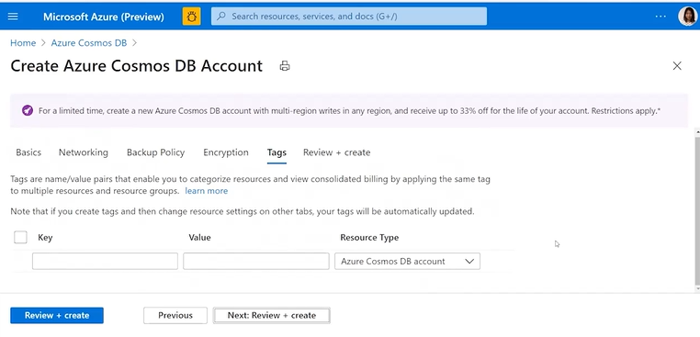

Select Review & Create

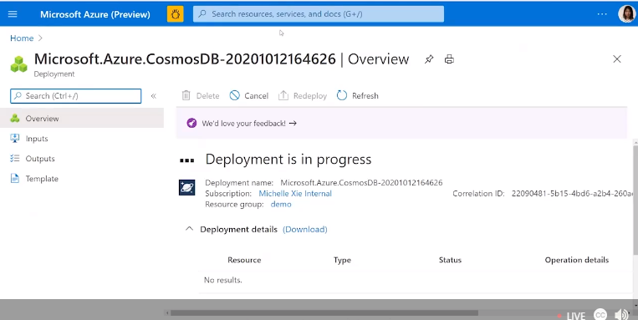

Created and deployed.

**Next setup a Cosmos DB then a container to store docs**

**DB Account Details**

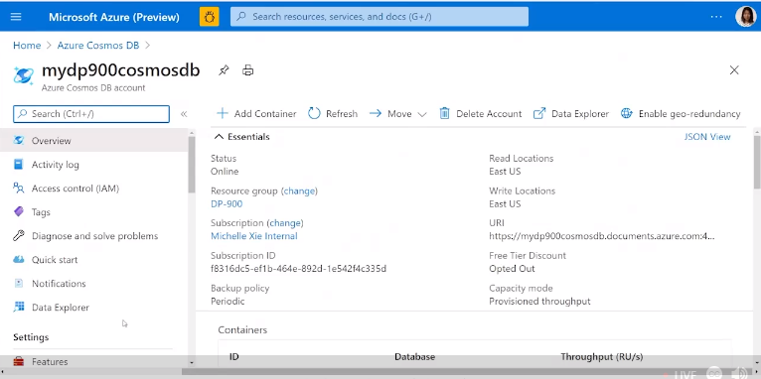

Search dbs and select the one you want

See overview of details, Endpoints, regions, etc

**Data Explorer Menu**

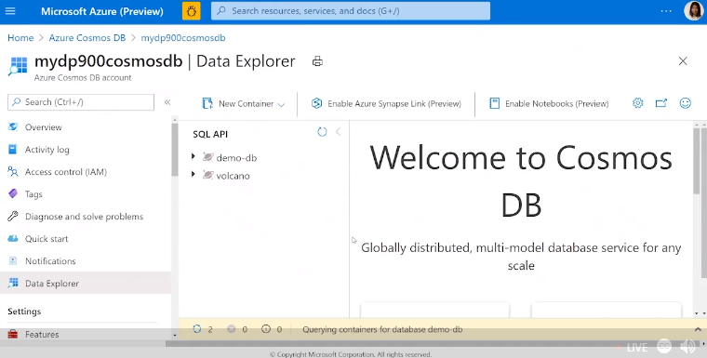

Can create dbases and containers from here.

**Sample**

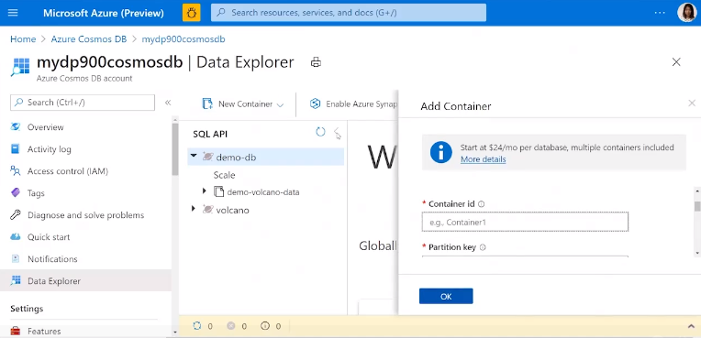

Can create a new container

Specify RU/s for throughput – can chose manual or scale

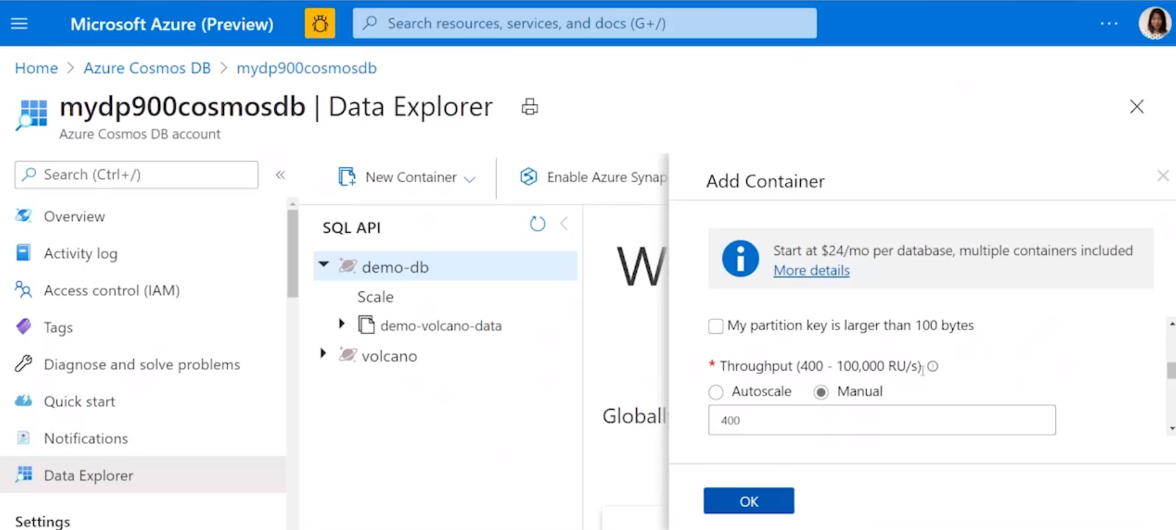

Creates container inside Azure Cosmos DB

## Migrate Data to Azure Cosmos Dbase

Tool can be downloaded from GitHub

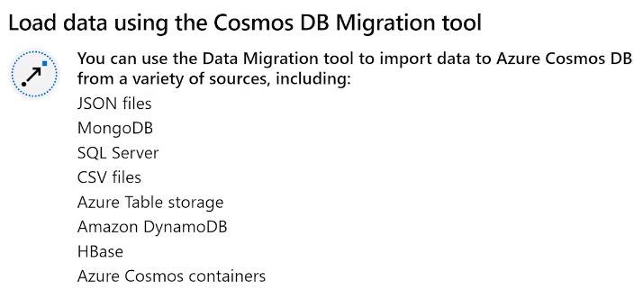

Download from GitHub

Guides you thru process of migrating databases to CosmosDB

Can also be used to export data from CosmosDB to a container or blob

**Migration Tool**

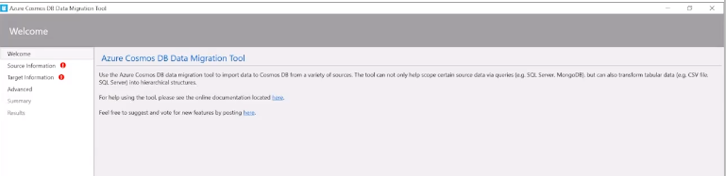

Need to Add

* Source – your data to import, demo used json files
* Target – Azure Comos DB account, get connection string from ‘keys’ menu and dbase name (DataExplorer) from Azure Portal (see screen print below)

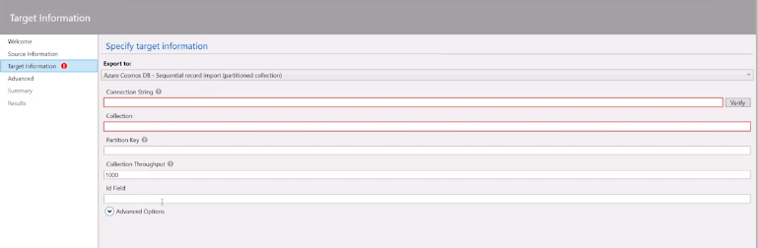

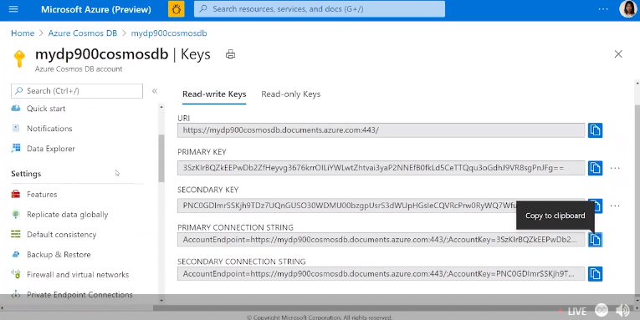

Verify checks connect to Azxure CosmosDB

Need to specify the Container to import json files too, include the partition key and configure the RU/s

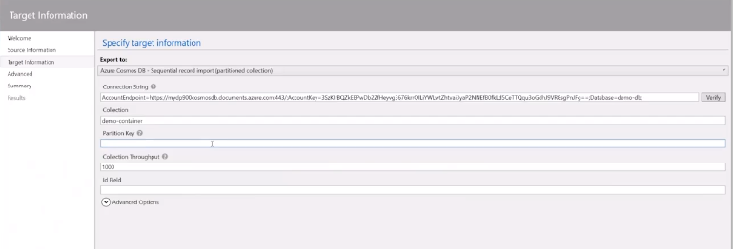

Summary of config of migration and hit import

## Azure authentication

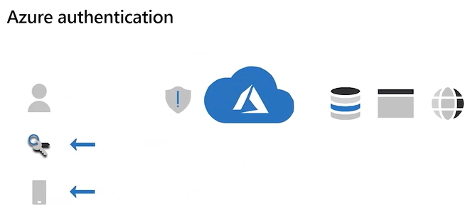

Usually password, can add 2FA

If success Azure creates authentication token for user/service and this is used/passed when try to access resource

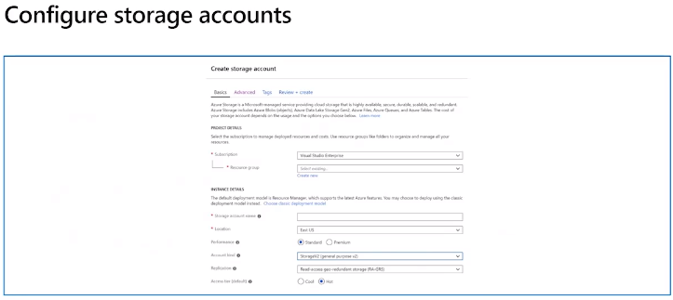

**Create Azure Storage Account**

Search for Storage Accounts & click Add

Same provisioning process as previously – names, regions, etc

## Azure Lake Storage Account

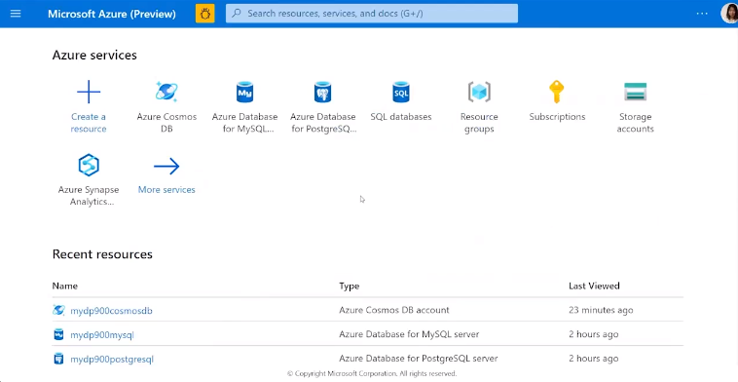

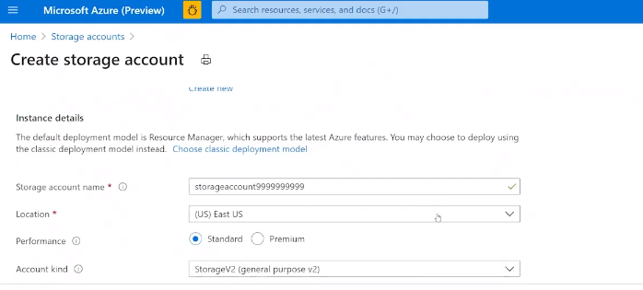

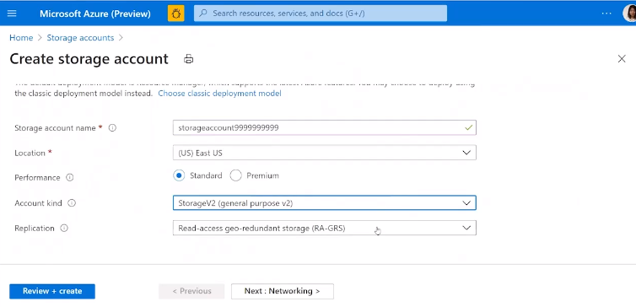

Lots of different Replication methods

Redundancy/replication options – can readup using MS docs

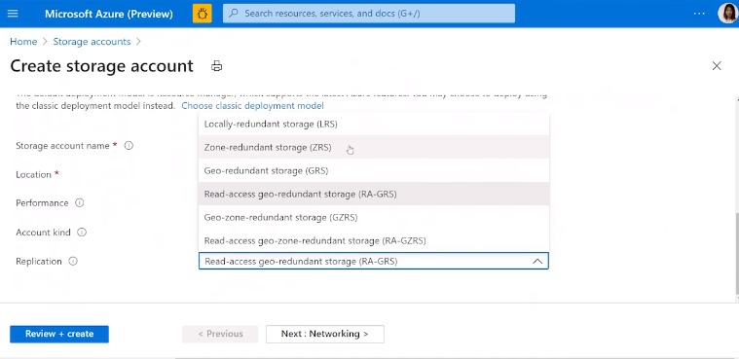

**Networking**

Select all, selected or no public networks

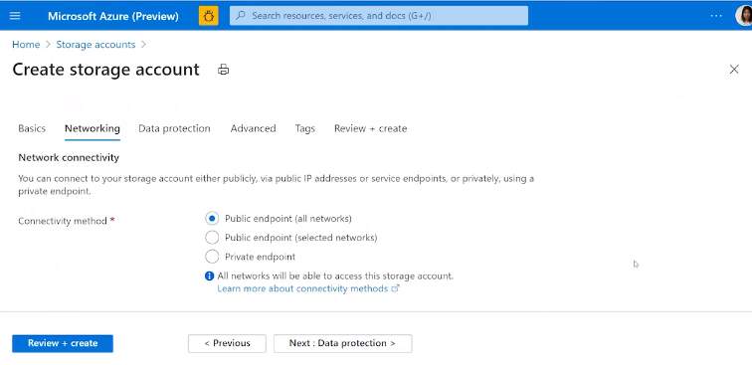

Choose what networks and routing rules

**Data Protection**

Configure how recover data in storage account

Point in time for containers

Soft delete, versioning from blobs

etc

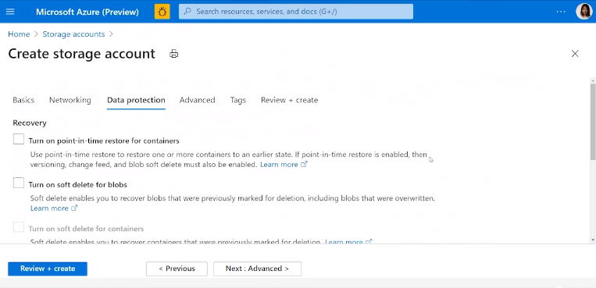

Turn on different recovery options, loggings, point in time, etc

**TLS Account**

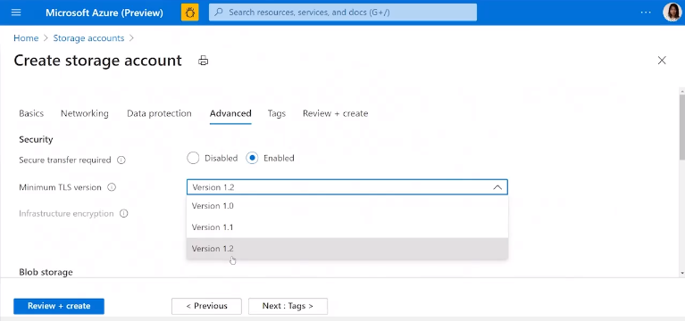

**Access Tiers and Data Lake Storage**

Hot, Cool Tiers

Data Lake Storage Gen2 – essentially data lake storage containing blobs

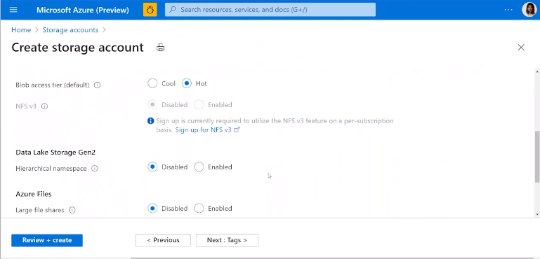

TAGS

Say what type of storage this is – metadata for storage account

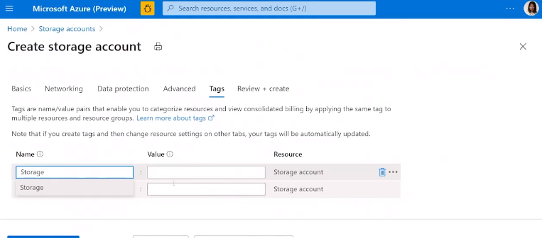

Review & Create

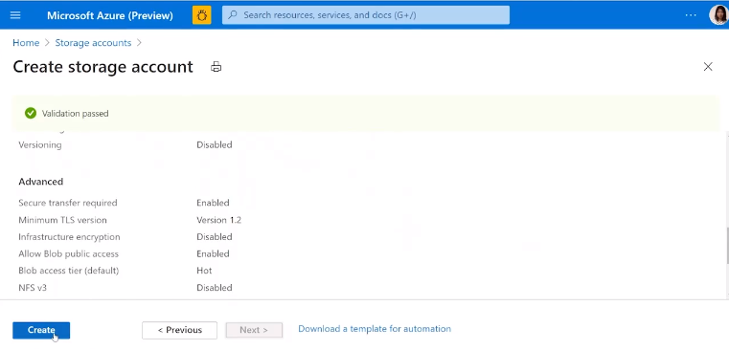

Create = creates data late storage

## Manage non-relational data stores in Azure

### Configure consistency

Inconsistencies can occur when latency from write to read

Write to one server then replicate to other servers. Latency could introduce risk of read/update happening prior to replication to server the application is using.

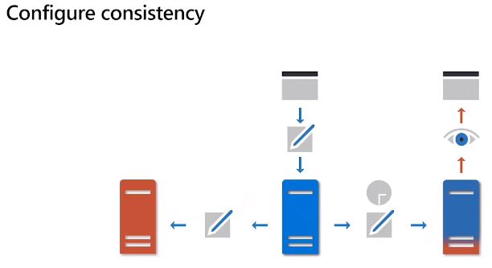

Options to manage inconsistences

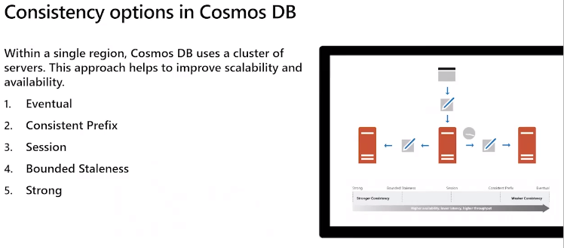

Each have pos & neg.

Eventual lowest latency but highest inconsistency risk

Strong has highest latency (may be unavailable) but highest accuracy (no inconsistency)

### Query

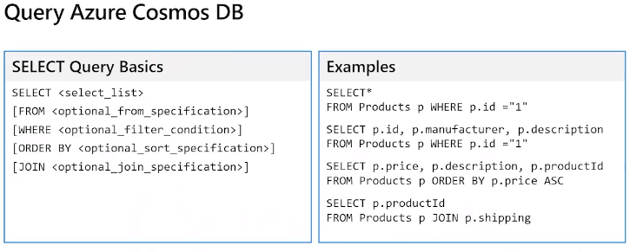

SQL API allows queries similar to SQL even tho it’s nosql DBASE

Results returned in json

Query must be within a single container

Query documents not data

**SELECT**

*= all attributes in the document

**From** = name of container

**Where** filter results – optional

**Order by** – optional

Results are returned as json

Can also have a **JOIN** clause to connect **fields** in the document to sub-documents (cannot do across different documents or containers)

### Demo using Core SQL API

Go to Azure and find the demo dbase and container

Right click to select - create a new SQL Query

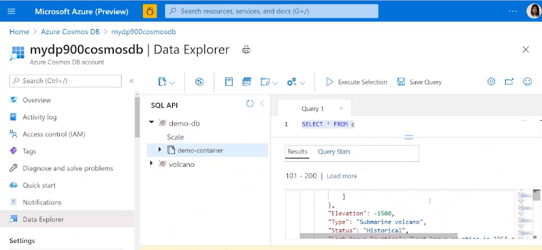

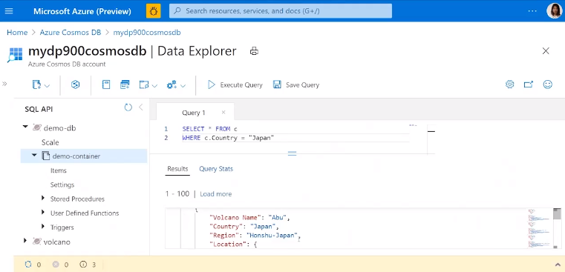

### Aggregate Functions

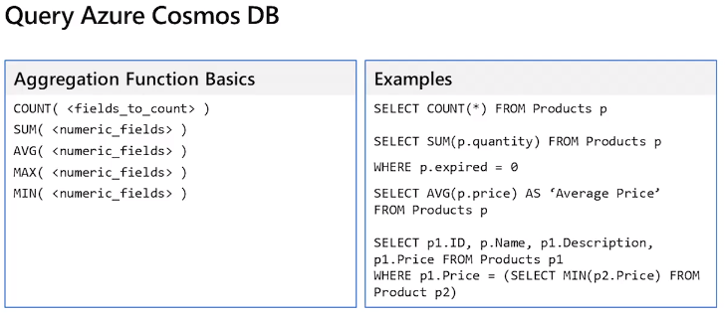

Count all the volcanos in Japan

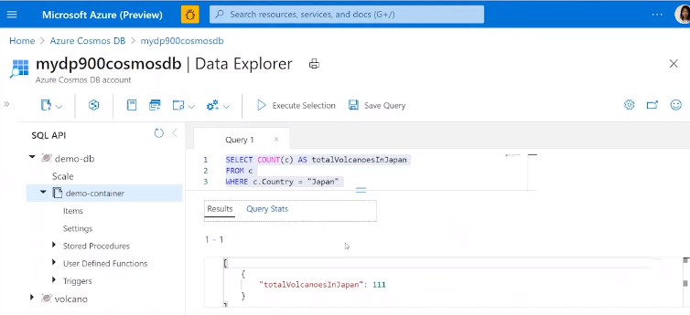

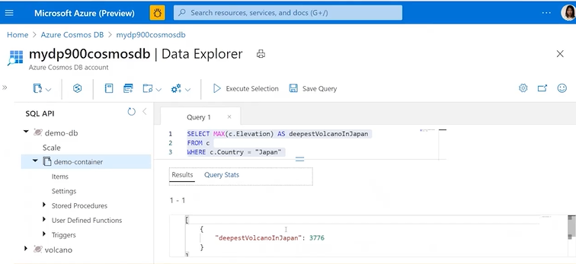

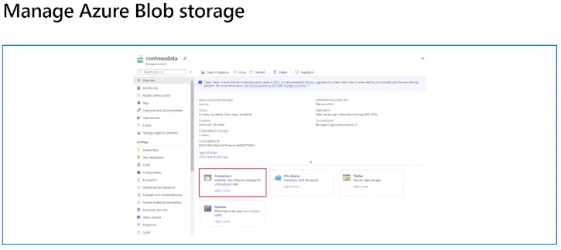

3 types of blobs as discussed previously – Block (static date – image, video), Page & Append (data as it grows in clumps)

To store blobs needs to create a container.

Container, folders, blobs.

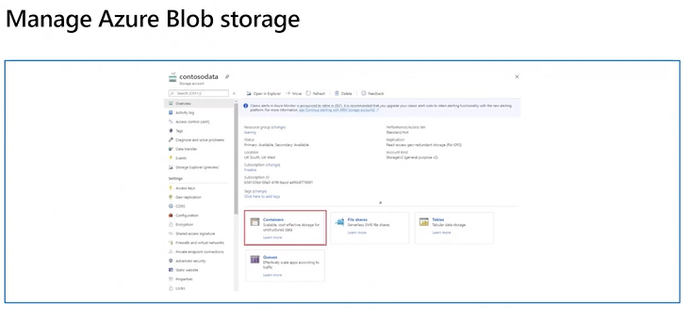

In your Storage Account you can create different storage options

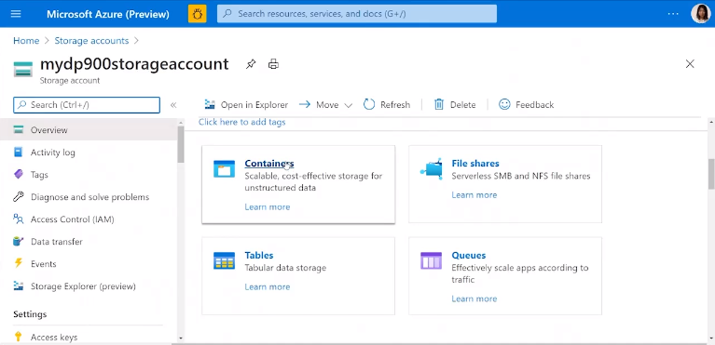

Pick Container

Add container

Complete the config details as per previous provisions e.g. names, access permissions, etc

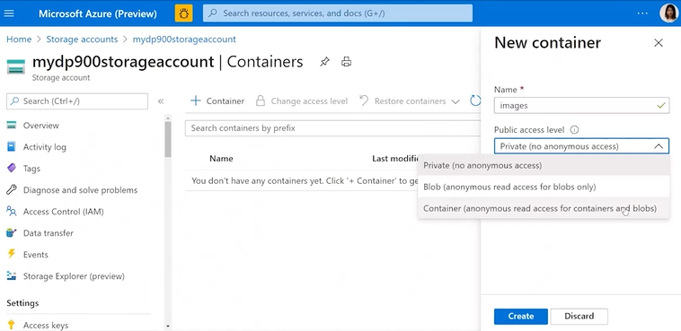

Container created

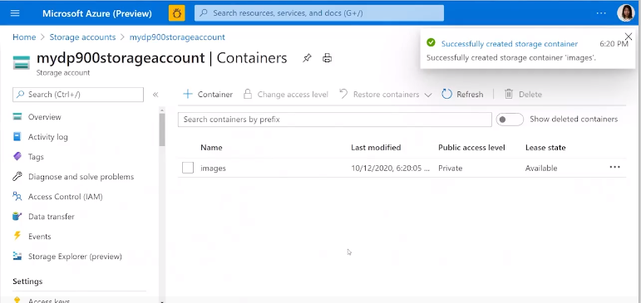

Upload files into your blob storage container

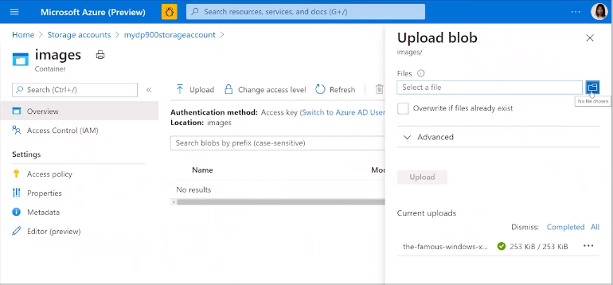

Because created blob as private need access token to get to see blob and contents

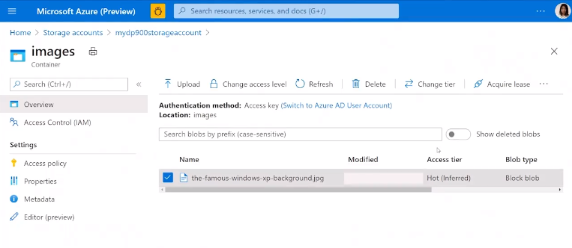

Three buttons RHS to create a SAS token for access to the blob

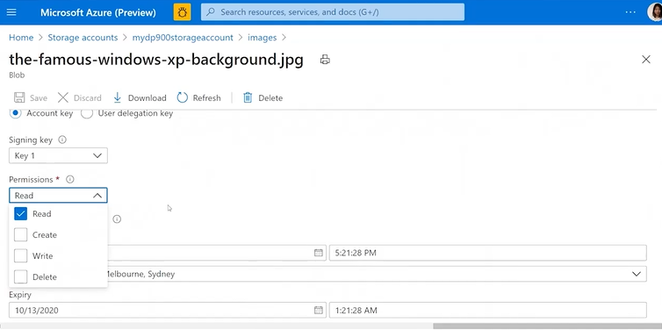

Generate SAS token url

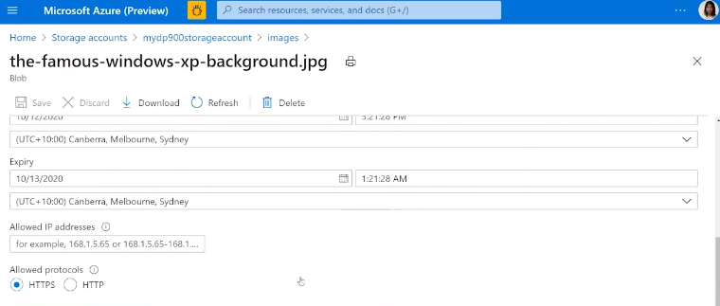

Use the SAS Token url, paste into browser to access blob and contents.

Delete blobs – select and hit delete. Soft delete not enabled so cannot recover.

### Create FileShare

Once given permissions users can use file storage

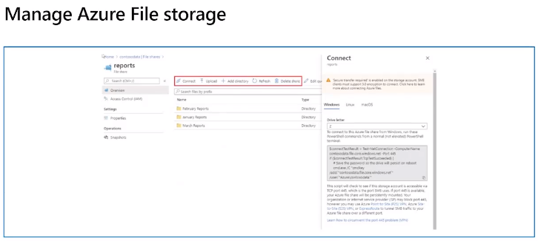

In an Azure Storage Account pick Fileshare

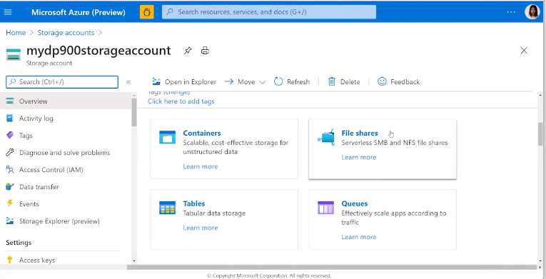

Select Fileshares and select Add

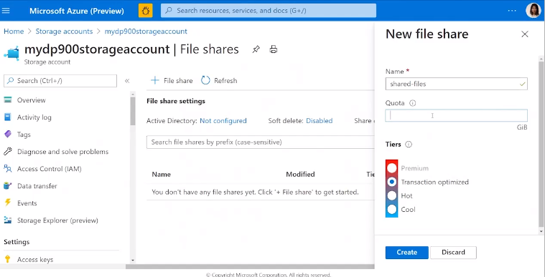

Need to add Quota and Tier

Click Create

### Copy to Fileshare

Can use utility AZ copy to copy files from local network to Azure Fileshare

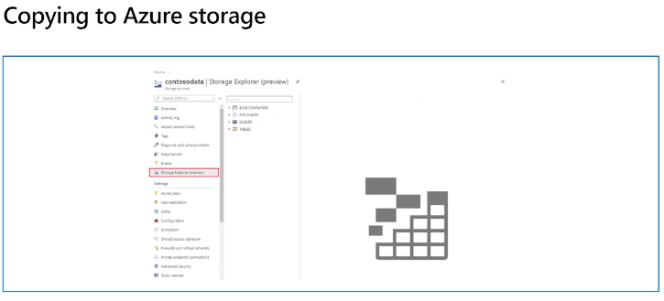

**Use utility Tool AZ Copy**

In Azure Portal go to the new Fileshare created above

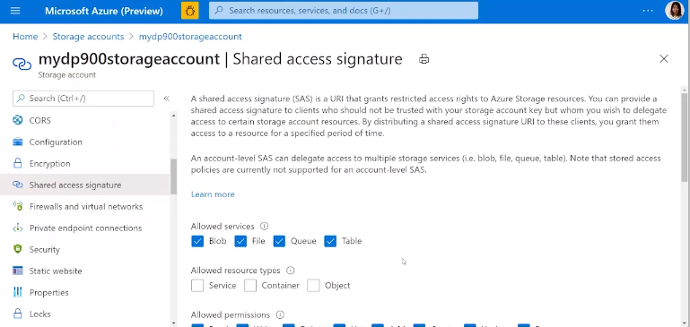

Generate SAS shared access file token

Select options for permissions and privacy

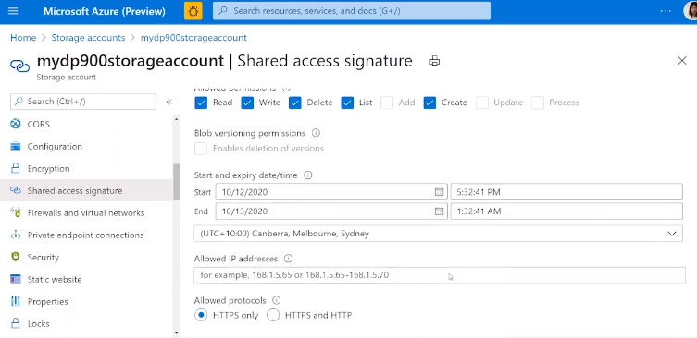

Generate SAS & Connection Key

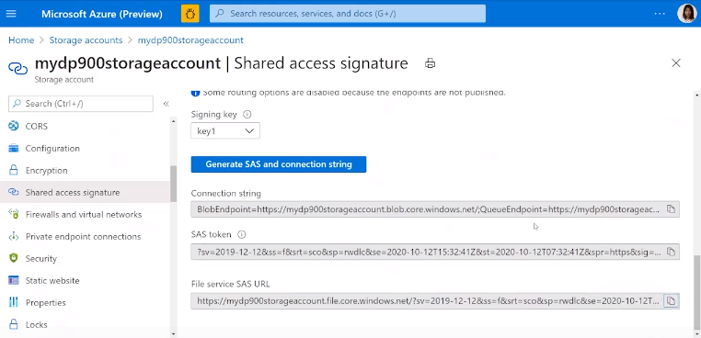

Now got the urls

Azure Cloud Shell – from Azure Portal

CLI or Powershell

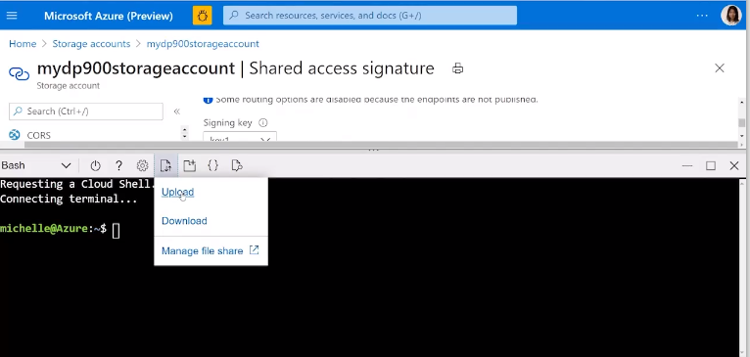

Upload the file

Then use the azcopy utility to upload the file.

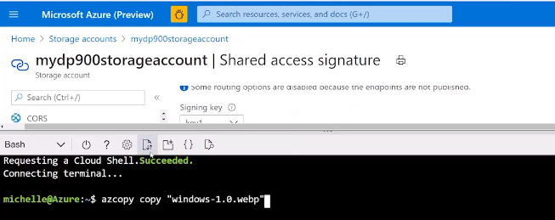

Can use the page with arrows icon to see a list of upload/downloaded files

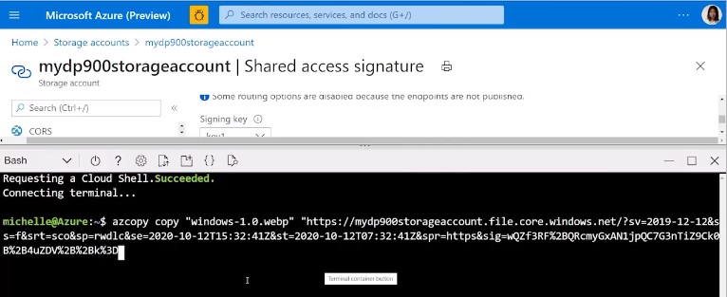

Add SAS url and adapt to include the fileshare and file name (before the ?sv)

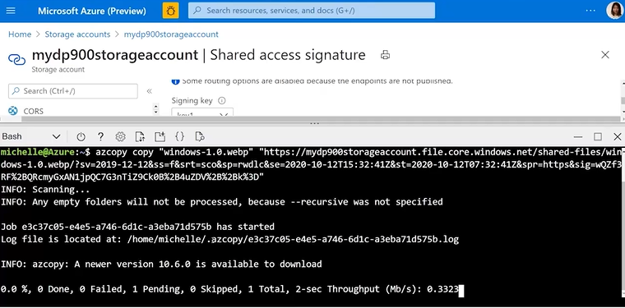

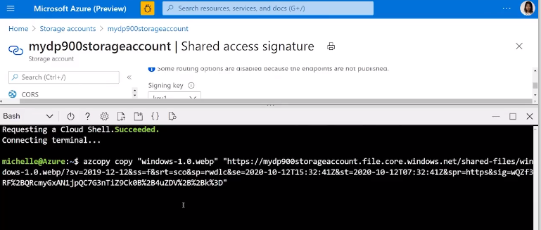

Go back to AZ Portal and should see the file.

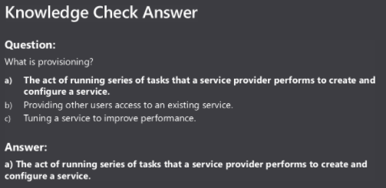

# Module 4 – Explore Modern Data Warehouse Analytics

## Examine components of a modern data warehouse

* Azure Data Factory gets data from relational and Non relation dbases – retrieves and formats = ingest
* Data Bricks – one way to perform data processing/transformation e.g. cleaning
* Azure Data Lake to store data
* Synaps Analytics to store clean business data – hub holding clean business data
* Azure Analysis services – insights from data – query the data, generate insights
* PowerBI – visulsation

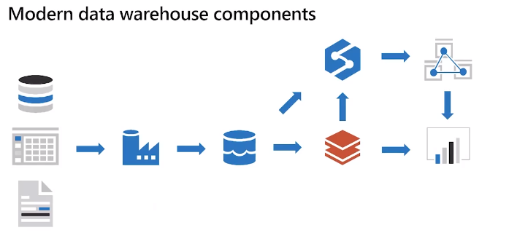

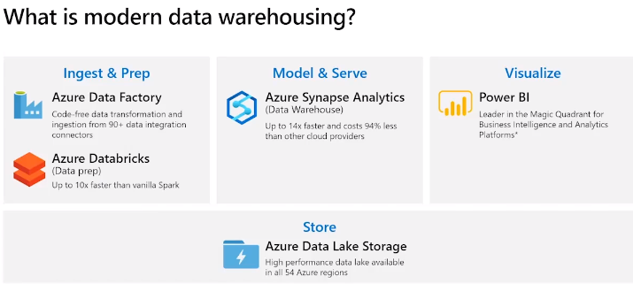

Relational, non relational , IoT

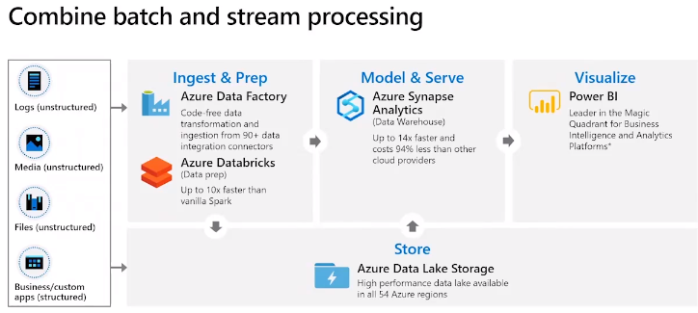

Mix of up-to-date/immediate data and historical data

* Up-to-date data capture of operational data
* Capture live stream, and group to batches for scheduled processing
* Historical – batch process at regular interval – stabilisation view, trends, sales month/quarter/year – increase/decrease production of items or in seasons

Must be able to access raw data and processed data

### Data Factory

Data integration service

Retrieve data to 1 or more data sources

Standardise/filter data

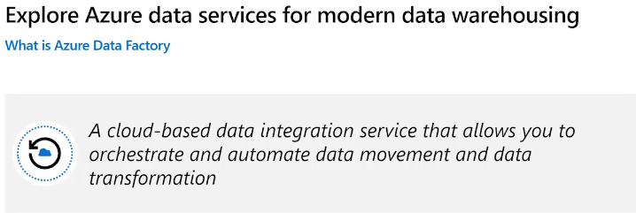

Data from lots of sources

Extract and filter data to keep relevant data

Can use Data Factory to set formats (dates) and other data standardisations

Create pipeline using own code or graphical UI tool in data factory – continuously or batch

Write out to data store

### Azure Data Lake

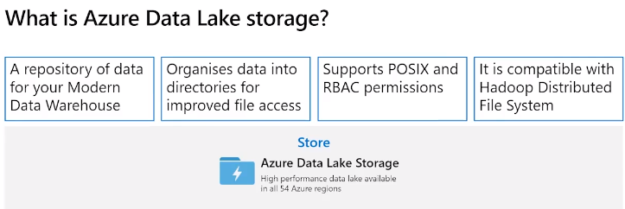

Resting point for raw data – staging point before transformed to format suitable for analysis

Extension of Azure blob storage organised into an almost infinite file storage system

### Azure Data Bricks

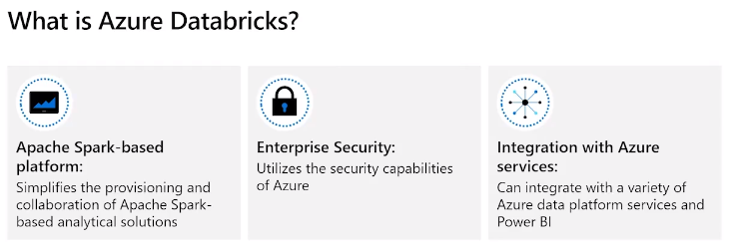

Apache Spark on top of Azure

Consume and process large amounts of data efficiently and quickly

Lots of libraries to use – including machine learning

Has graphical interface to write your processes – can write and test before implementing

Supports R, Python, Notebooks

Can perform continuous data process

Also supports structured stream processing – computations from the stream including updates

### Azure Synapse Analytics

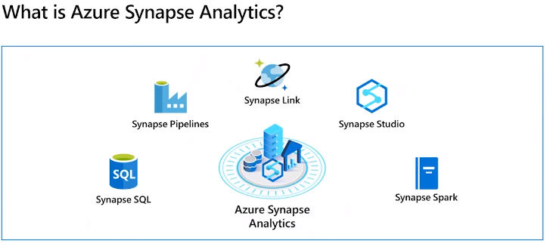

Get data from various sources including external, files, data lake, etc

Can transform and store ready for querying

Can store in locally service to make quicker so not always reading – not fetch and process each time

Process lots of data so suitable for analysing

### Azure Analysis Services

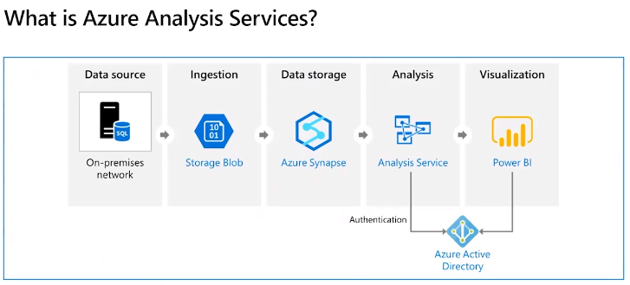

* Includes control nodes
* Can combine data from different sources
* Can build models from those sources to get results
* Includes graphical designer to allow you to join, combine, filter data and analyse and model data
* Overlap with Azure Synapse Analytics, more suited for processing smaller scale data (2TB), supports high reader concurrently, detailed analysis
* Analysis Services – small numbers (2TB) supports fast processing
* Synapse Analytics – bigger datasets
* Often combine both – large amount ingested that needs processing = Synapse Analytics then use Synapse Analytics to do the drill down, detailed analysis
* Synapse Analytics – process large amounts of data into models
* Analysis Services – detailed interrogation into data find insights
* Visualisation in PowerBI

### HD Insights

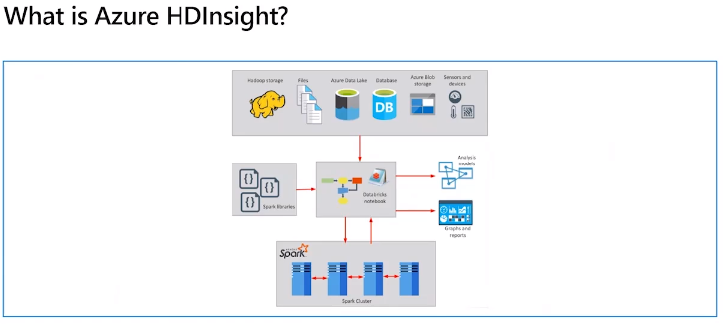

Build data processing services

Running Spark instead of Azure Synapse Analytics

Cluster model across many servers

Also support Hadoop & Hive

## Explore data ingestion in Azure

Ingestion is the most import part – as don’t want to lose data!

Fast enough to capture all relevant data

Need compute power to processing timely manner

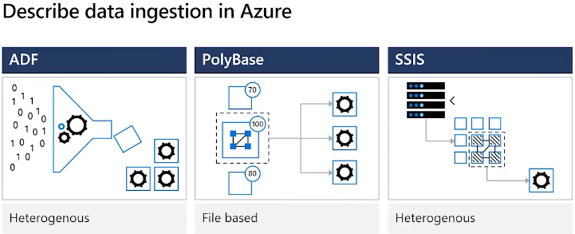

**Azure Data Factory**

Azure Data Factory - clean and reform data before loading into data warehouse

Azure Data Factory – interconnected systems allow load static data, streaming data and continually update data in the data warehouse

**PolyBase**

SQL Server - TSQL read data from external data sources and appear like data in normal table

Read CosmosDB, Hadoop, Spark, Oracle, MongoDB, etc

Can transfer from external into table

Run queries join data from multiple data sources

**SSIS**

SSIS – SQL Servier Ingreated Services – integrated data tools

Manage objects, cleaning data, mining data etc

SSIS – Part of SQL Server – can use tools within for ETL

Programe service object models and code custom

Part of SQL Server

Graphical tool to create these objects

On-prem utility but can use ADF to run existing SSIS packages

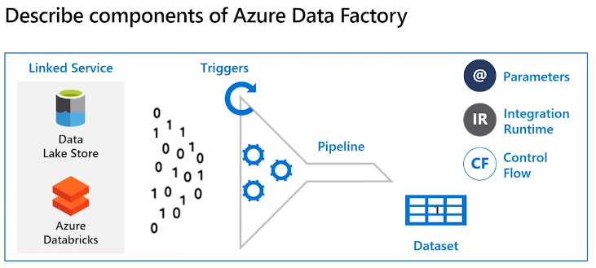

Linked service

Provides info to connect to source and destination

Pipeline

Logical grouping of tasks to perform on your data

Don’t need to be linear, can use logical lops, for loops, paths based on if conditions

Can run manually or use a trigger (schedule based on time or on event occurs e.g. file lands)

Dataset

Data to ingest and store

Specifies how data is structure

Also can specify unstructured

Connects to linked service to specify input and output storage accounts including specification of types

Can use Azure Data Factory to build a pipeline to collect, process and ingest data

Can run manual or schedule at intervals or set times or when an event occurs

Dataset connect to input/output using a link service

Can be structured or unstructured

Define input and then describe table as output

## Explore data storage and provisioning in Azure

### Azure Synapse Analytics

Data comes from many sources

Can extract, transform and analyse

Can run parallel processing across massive data sets – big data

Need rapid data ingestion and processing

Capacity and compute power to extract and process

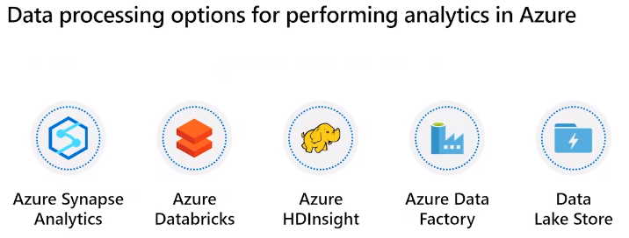

Can run parallel processing across big datasets.

Rapid data ingestion and processing

Capacity to perform processing and store data

#### Data Bricks

Integrated with Azure to enhance processing data

1 click setup to allow collaboration of engineers, scientists, Bas, etc

Can access data from all of the above

Can use data warehouses to store and analyse/transform data

Can process streaming data

Processing engine Apache Spark – parallel processing engine for big data

Spark distributes work across many computers – parallel processing – reduce time to perform work

Spark – python, R, scala, java, sql. Lots of libraries including stat analysis and ML and graphics

Modules for analysis, machine learning, graphics, etc

Write data bricks applications using a notebook – cell with block code for each function - e.g. read data, process, model, save

### Azure Synapse Analytics

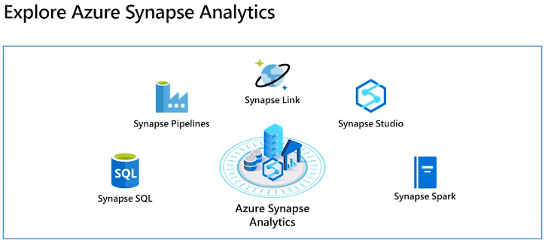

Lots of tools within Synapse Analytics

Can write data processing logic in lots of languages, C#, Python, etc

Pipeline – logical grouping of activities that together perm a tasks to perform a functions – read various sources, process/transform/combine, save

Link – allows to link to other data sources and services e.g. CosmosDB.

Studio – web user interface to access these tools, create spark and sql pools, run pipelines, configure links to external data sources.

### Demo Load Data to Azure Synapse Analytics

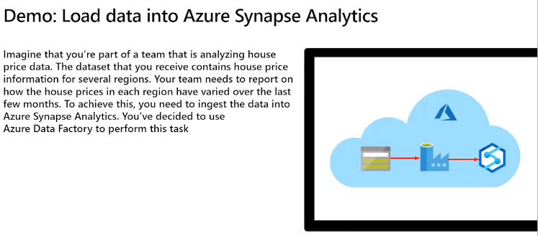

House price data

Report on prices in regions vary over last couple months

Ingest into Azure synapse analytics using ADF to read the data

Azure Portal

Create storage Account – Azure Storage Account

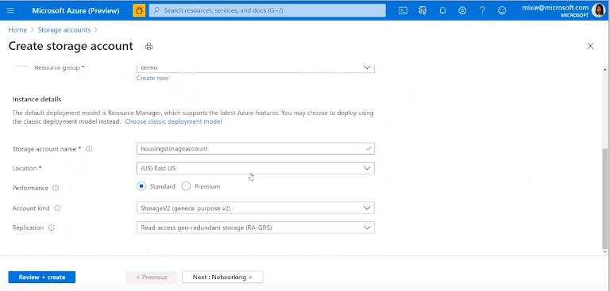

Create a storage account and put in relevant storage account group

Fill in all the fields for provisioning

**Setup Synapse Analytics**

Complete the usual provisioning screens

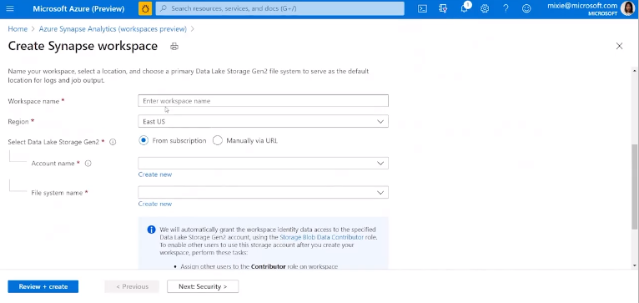

Need to create Azure Storage Lake and Filesystem

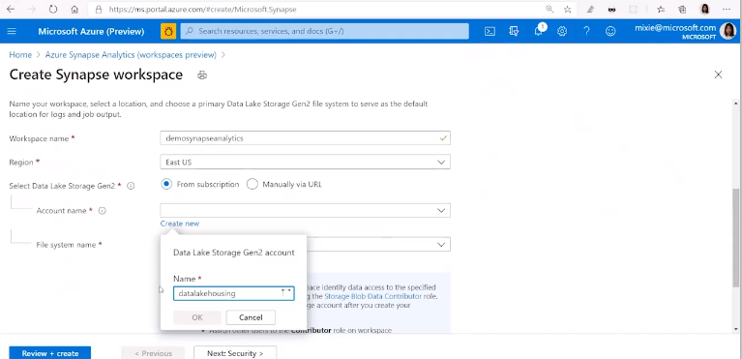

Also need to give it a filesystem name

Need to add security

Put in user/pass

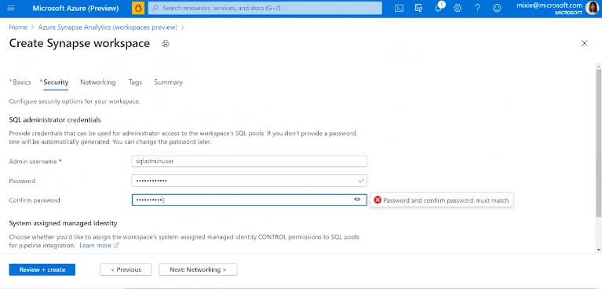

Configure access and tags

Summary & create

Go to Storage Account created above

Scroll on left to find file storage

Create new fileshare

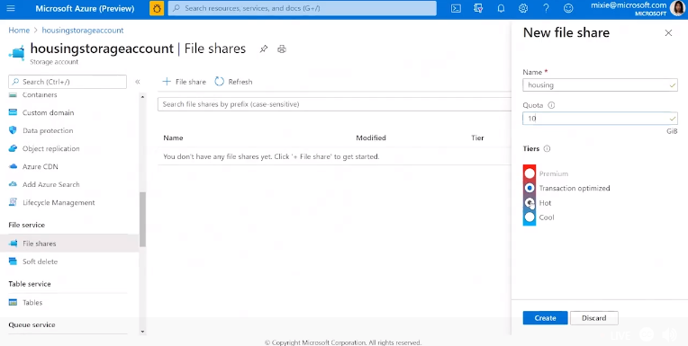

Name and other config params

Create

Upload files into File Storage

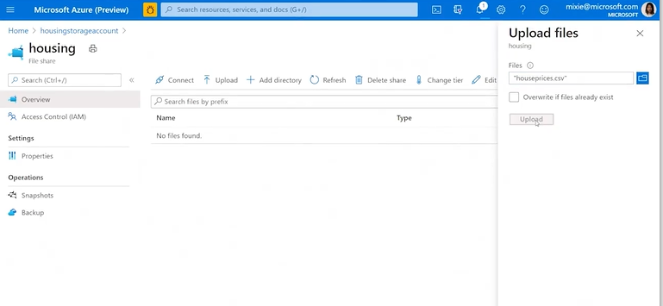

Create a Data Factory

Lookup DataFactory and Add

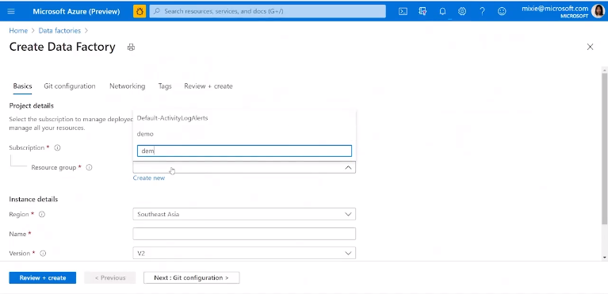

Configure – subscription, resource group, etc

Git config

Networking

Tags

Review & Create

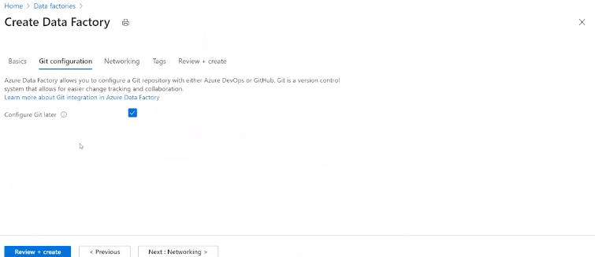

Go into resource group and find Synapse Analytics created above

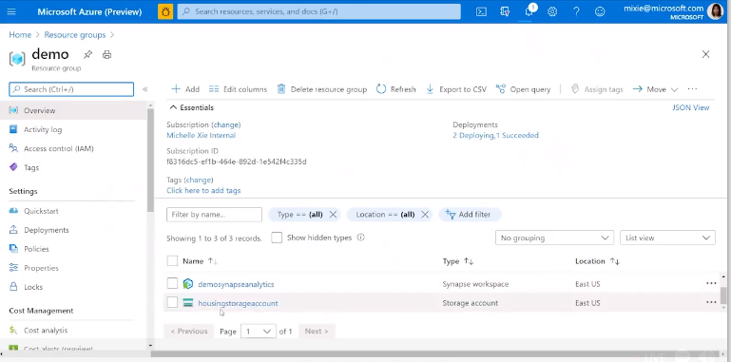

Scroll down and open Synapse Studio

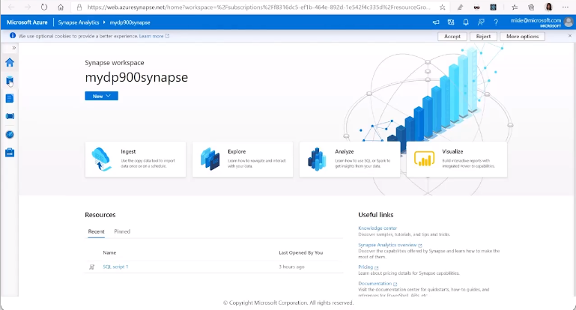

Scroll down to open Synapse Studio

Access dbase from LHS menu to access data

Add a new SQL Pool

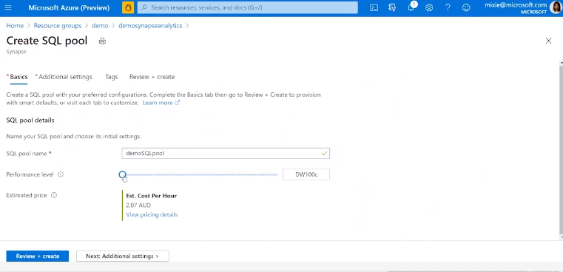

Additional Settings – scale and performance levels

Additional setting – data source (can select none), tags

Review & Create

Takes a few minutes to provision

Open Synapse Analytics Workspace

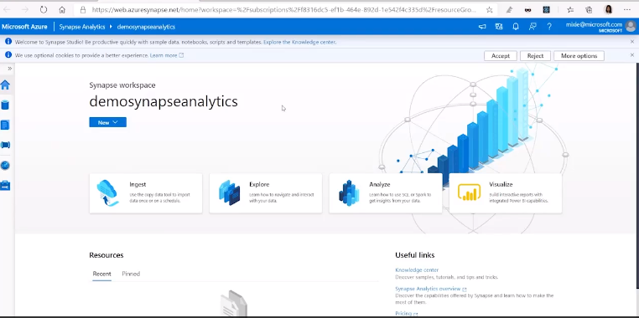

Go to Data on LHS and open dbases

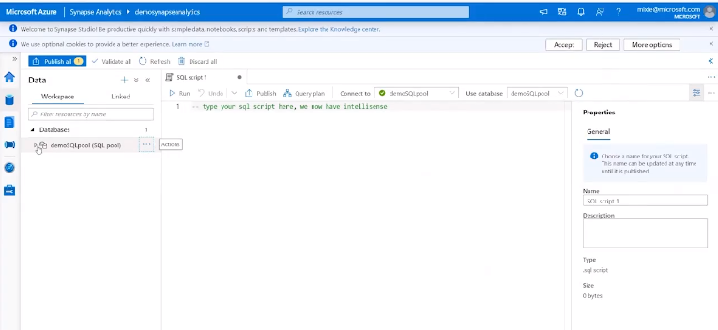

Create table – housing data so can insert file into Synapse analytics

Enter sql into the script tab and run

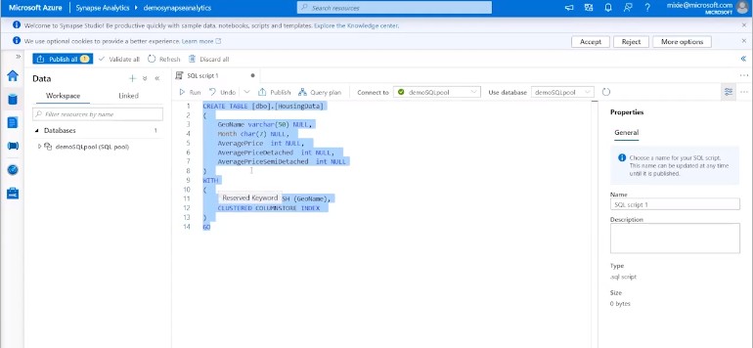

Table now in SQL Pool

Find DataFactory Created above

Click Author and Monitor

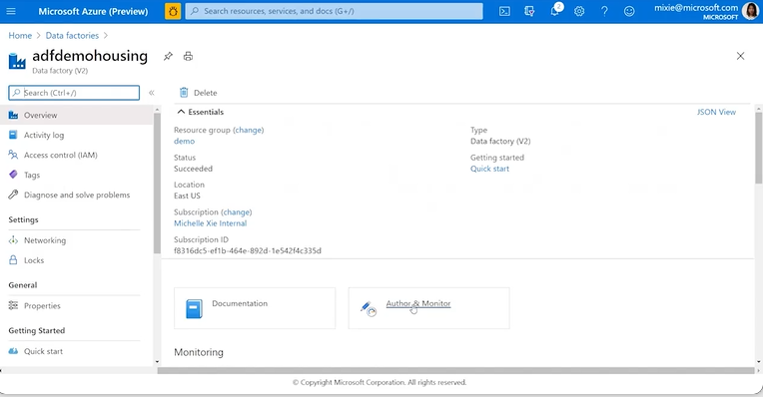

Open the ADF

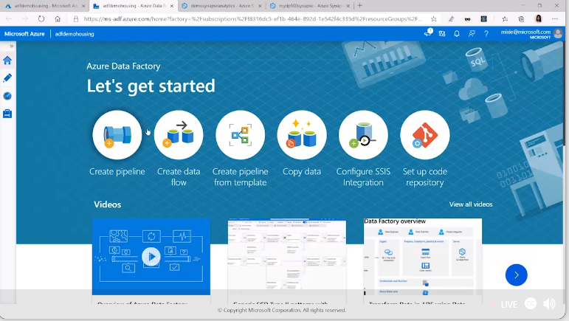

Can do various tasks

We are copying data

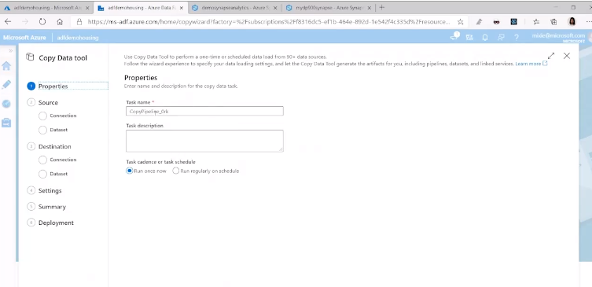

Create connection to get source data

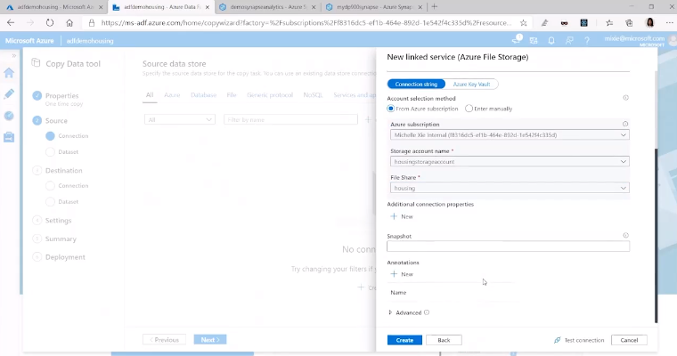

Creates connection to Azure File Storage

Find file in fileshare

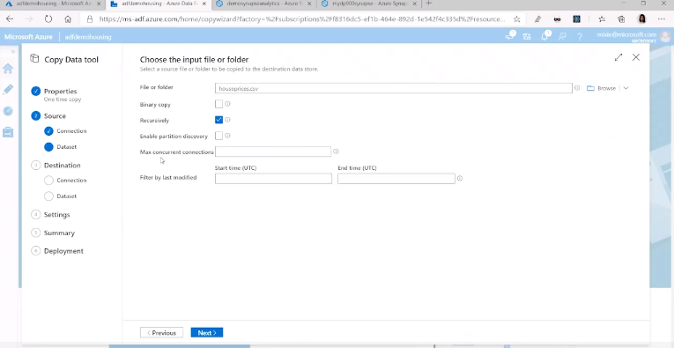

Specify file format settings

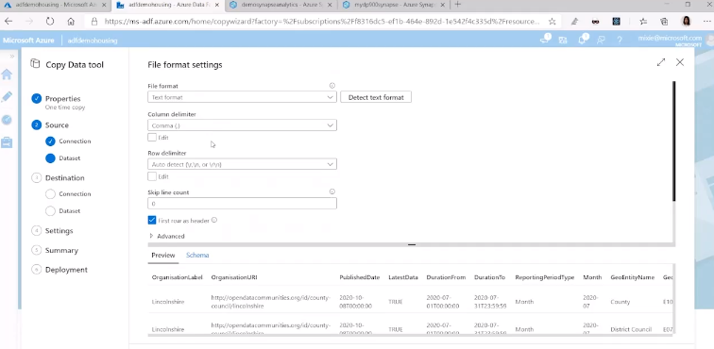

Configure destination filestore – synapse analytics

Create a new connection to synapse including the connection string and dbase

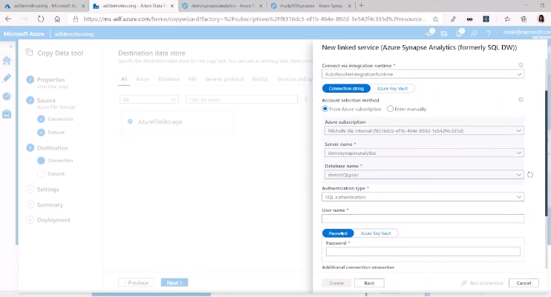

Test connection

Create

Next

Map File in filestore to table in Azure Synapse Analytics

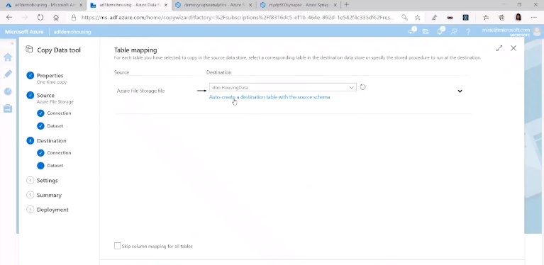

Configure setting for the ingest

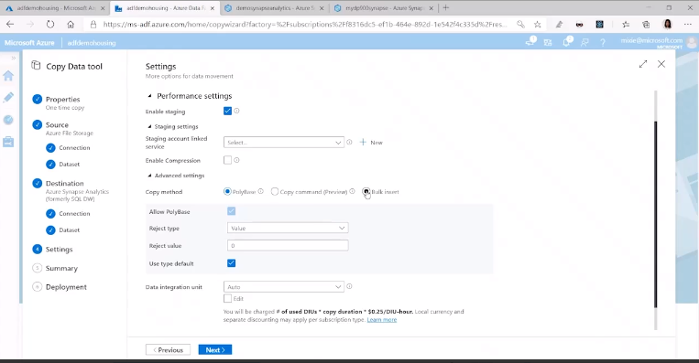

Can see field mappings

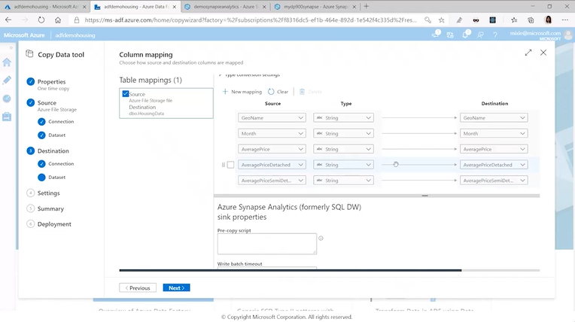

Can set setting, saving, type of upload = bulk, copy parallism, data integration units (auto or pick)

Shows Summary

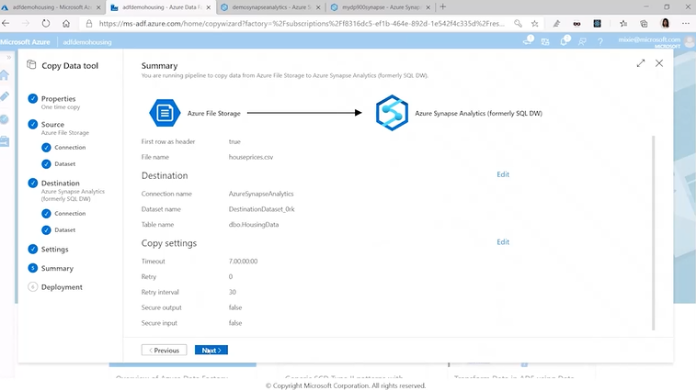

Review & Next

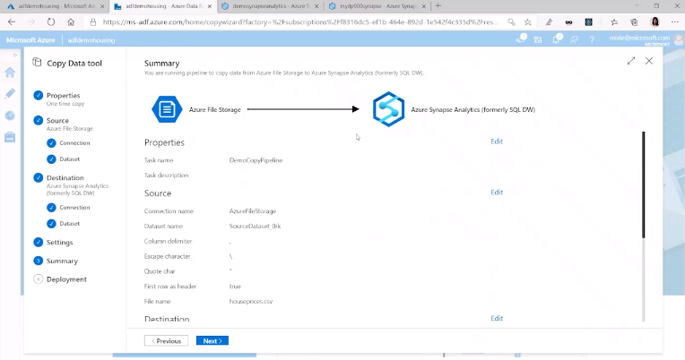

Next

Will now validate and run pipeline

Go back to Synapse Analytics Workspace

Refresh

Check data copied over – check the 1st 100 rows in table

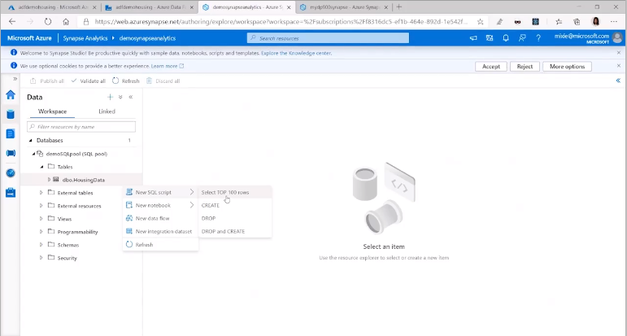

## Get started building with Power BI

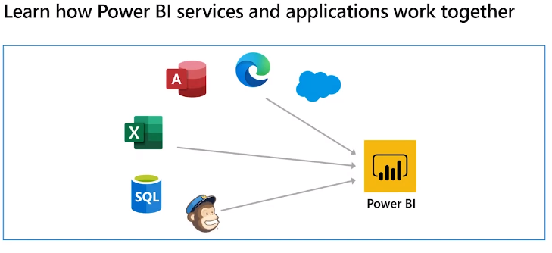

Work together to join unrelated data sources

Connect data sources

Create reports and visualisations

Also analytics and decision based engines

* PowerBI desktop – desktop application
* Servers – online SaaS
* Mobile App – mobile app running on Win, OS, Android

Publish reports to PowerBI servers or mobile apps to access your dashboards

PowerBI follows common flow

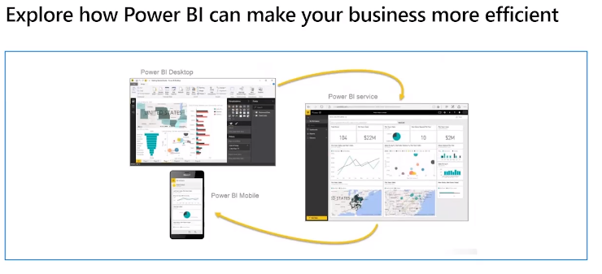

Data into PowerBI desktop

Build dashboards in desktop

Share dashboards with others thru server or mobile app

PowerBI Building blocks

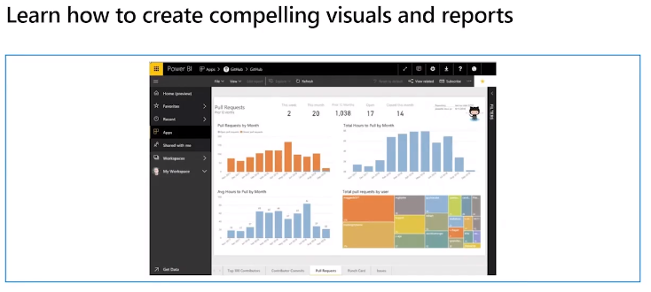

**Visualisation**

visual representation of data – chart, map, etc

simple chart

complex gradient colour map

Easier interpretation of data than looking at

**Datasets**

Collection of data

Simple – excel S/S

Complex – many data sources to join together – 3 db fields, S/S, results from survey – combine to a single dataset

**Report**

Collections of visualisations that appear on the same page/group of pages – relate to each other

Arrange in story telling way

**Dashboards**

Collection of visuals from a single page that you can share with others

Groups of visuals that present insights, tell a story

Must be a single page – canvass

**Tile**

Single visualisation on a report or dashboard

Usually a rectangle box

Can group with other tiles

Viewing or consuming a dashboard or report (not the creator)

Can interact but cannot change the format or layout

Collection of services apps and connectors to group data and create visualisations.

Realtime Azure SQL database and other sources to present a moment by moment dataset.

Turn data into actionable insights.

